Man-made ligament could replace ruptured ACLs
By Ben Coxworth
January 2, 2015
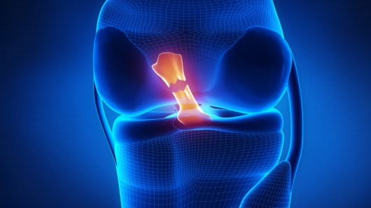
An illustration depicting a ruptured ACL (Image: Shutterstock)
If you follow sports at all, then you've probably heard about athletes rupturing their ACL, or anterior cruciate ligament. It connects the femur to the tibia, and once it breaks, it's incapable of healing. Treatment most often involves reconstructing the ACL using grafts from the patellar tendon, which connects the patella (aka the kneecap) to the tibia – although this can present problems of its own. Now, scientists at Northwestern University in Illinois are creating a man-made replacement ACL, which could make treatment much more effective.
According to professor of biomedical engineering Guillermo Ameer, who is leading the project, the use of patellar tendon grafts often results in knee discomfort that never goes away. This isn't surprising, as the procedure involves removing part of the existing patellar tendon to take the place of the ACL – in fact, what's left of the patellar tendon can subsequently end up rupturing, too.
That's where his team's engineered ACL comes in. Its main body is made from braided polyester fibers, with a tensile strength similar to that of the natural ligament. At either end of it, however, those fibers are blended into a mixture of a porous antioxidant biomaterial developed previously in his lab, and hydroxyapatite (a form of calcium) nanocrystals – these occur naturally in bones and teeth.
In rabbit studies, holes were drilled in the femur and tibia, in order to receive each end of the artificial ACL. After the ends had been inserted and anchored in place, the animals' surrounding bone and tissue cells began migrating into the pores of the biomaterial/nanocrystal mix. It is hoped that given time, this could result in the ends of the ACL being completely incorporated into the femur and tibia.
"The engineered ligament is biocompatible and can stabilize the knee, allowing the animal to function," said Ameer. "Most importantly, we may have found a way to integrate an artificial ligament with native bone."
More studies will be required before human trials can begin. A paper on the research was recently published in the Journal of Tissue Engineering and Regenerative Medicine.
Source: Northwestern University

